**INTRO TO AI**

**PYTHON LAB 1 ANALYSIS REPORT**

**DANIYAL AHMED**

**301152472**

1. Add a new food item at location 9 in the park



* Create new Food object called dogFood1
* Use add_thing to add dogFood1 to the park environment at location = 9

1. Add a new thing to the environment name it “Person”.



* Create new class Person

1. Create two instances (objects) of the “Person” class and name the first instance your first name and set the location of this instance to be 3 in the park environment. Name the second instance your last name and set the location of this instance to be 12 in the park environment.

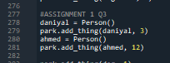

* Create new Person object called daniyal
* Use add_thing to add daniyal to the park environment at location = 3
* Create new Person object called ahmed
* Use add_thing to add ahmed to the park environment at location = 12

1. Add a new action to the percepts for the BlindDog agent as follows: If the agent encounters a person at the park to bark. (hint: Check how action “drink” operates, there are many classes that need to be changed in the code)

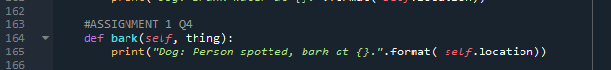

* Define bark in the abstract class for BlindDog, make it print a string phrase

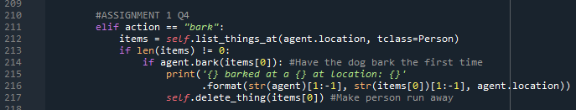

* Added action bark into the execute_action method in the Park Environment class
* Create items list that contains all things at specified location
* Check to make sure there is 1 or more items in location
* Make agent bark and print string phrase
* Delete the thing that the action was executed at (make Person thing run away)

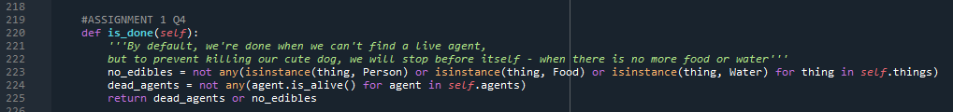

* Boolean check for things remaining in environment, return true or false
* Added bark in the no_edibles check (didn’t make new statement called run_a way() for example since the code works the same regardless)

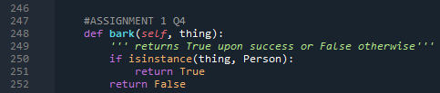

* Returns true if there is an instance of Person at whichever location
* Returns false if nothing at location

1. Run the park environment for 18 steps check the results and take a screenshot of the results, it has to be a full screen showing the console output



* Use run() function from the Environment class to simulate a dog walking 18 steps

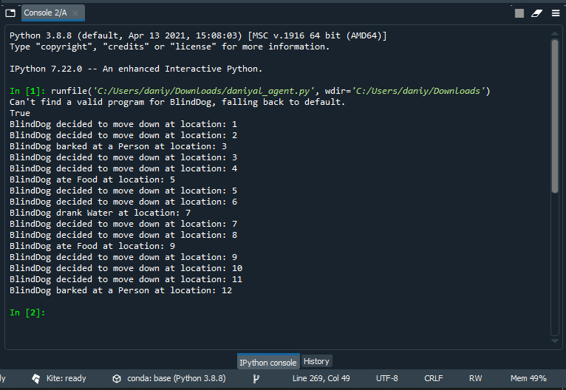

* Code only runs 12 lines, since in Q4 we’ve added Person in the check if there are things remaining in the environment
* At the 12th step, the agent realizes there are no more things in the environment, and stops proceeding1

CLASS DIAGRAM

